LAB # 5

CLASS DIAGRAM

TASK 1:

Draw class diagram for library management system

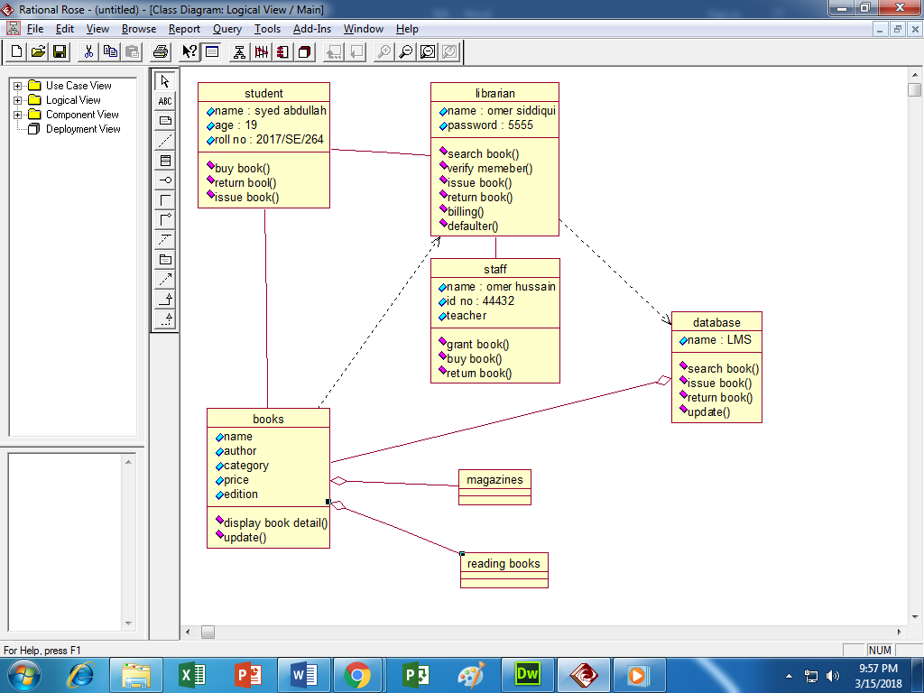

TASK 2:

Draw class diagram on hospital management system

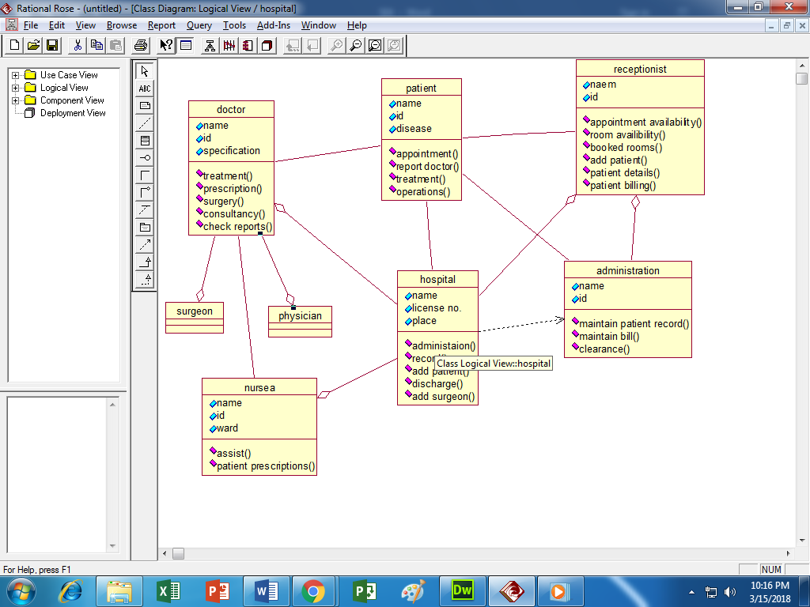

TASK 3:

Draw class diagram for atm management system

